RIX 2024- Batch 1_ Software & Manual Testing Practical Assessment

12576 Nisanth Saravanan

Online Courier Management System

An online courier management system is a software application that is used to manage the process of sending and tracking packages and documents through a courier service. This typically includes functions such as creating shipping labels, tracking packages, and generating reports. This project is a useful tool for businesses and individuals who need to send packages and documents through a courier service on a regular basis.

W3H Analysis

Project Title: Online Courier Management System
What? |  | How?
1. What are the necessary modules?  A: Modules Needed:  1) Login and Registration.  2) Admin Dashboard.  3)User Dashboard.  2. What are the necessary functionalities of Login and Registration Modules?  A: Login and Registration Module:  1) Register User.  2) Login as User.  3) Login as Admin.  3. What are the necessary functionalities of Admin Dashboard?  A: Admin Dashboard:  1) Perform CRUD Operation with Shipments.  2) Filter Shipments.  4. What are the necessary functionalities of User Dashboard?  A: User Dashboard:  1) Filter Shipments. |  | Login and Registration Module:  1) Register User:  Method 1: Use Simple Form Page.  Method 2: Use a Modular Form Page.  Method 3: Use Google OAuth and other 3rd party services.  2) Login as User:  Method 1: Use Simple Form.  Method 2: Use a Modular Form.  Method 3: Use 3rd party services.  3) Login as Admin:  Method 1: Hard Code the Admin accounts.  Method 2: Have an Admin Login Page.  Method 3: Have a separate Register + Login for admins.  Admin Dashboard:  1) Perform CRUD Operation with Shipments:  Method 1: Use Simple Forms and Buttons to perform CRUD.  Method 2: Have separate pages for each operation  Method 3: Use Modals.  2) Filter Shipments:  Method 1: Use a simple search bar.  Method 2: Have tables and sorting buttons.  Method 3: Have a separate page to pick out exact results.  User Dashboard:  1) Filter Shipments:  Method 1: Use a simple search bar.  Method 2: Have tables and sorting buttons.  Method 3: Have a separate page to pick out exact results.
Login and Registration Module:  1) Register User:  Method 1: Use Simple Form Page.  A: Fits the use case as a simple and easy to work with solution. It is also effective in resolving the requirement in hand.  2) Login as User:  Method 1: Use Simple Form.  A: Fits the use case as a simple and easy to work with solution. It is also effective in resolving the requirement in hand.  3) Login as Admin:  Method 1: Hard Code the Admin accounts.  A: Fits the use case as a simple and easy to work with solution. It is also effective in resolving the requirement in hand.  Admin Dashboard:  1) Perform CRUD Operation with Shipments:  Method 1: Use Simple Forms and Buttons to perform CRUD.  A: Fits the use case as a simple and easy to work with solution. It is also effective in resolving the requirement in hand.  2) Filter Shipments:  Method 1: Use a simple search bar.  A: Fits the use case as a simple and easy to work with solution. It is also effective in resolving the requirement in hand.  User Dashboard:  1) Filter Shipments:  Method 1: Use a simple search bar.  A: Fits the use case as a simple and easy to work with solution. It is also effective in resolving the requirement in hand. |  | Login and Registration Module:  1) Register User:  Method 2: Use a Modular Form Page.  Method 3: Use Google OAuth and other 3rd party services.  A: Increases the complexity of the application with no valid reason in hand. Also increases the overall scale of the project with no time to support its completion.  2) Login as User:  Method 2: Use a Modular Form.  Method 3: Use 3rd party services.  A: Increases the complexity of the application with no valid reason in hand. Also increases the overall scale of the project with no time to support its completion.  3) Login as Admin:  Method 2: Have an Admin Login Page.  Method 3: Have a separate Register + Login for admins.  A: Increases the complexity of the application with no valid reason in hand. Also increases the overall scale of the project with no time to support its completion.  Admin Dashboard:  1) Perform CRUD Operation with Shipments:  Method 2: Have separate pages for each operation  Method 3: Use Modals.  A: Increases the complexity of the application with no valid reason in hand. Also increases the overall scale of the project with no time to support its completion.  2) Filter Shipments:  Method 2: Have tables and sorting buttons.  Method 3: Have a separate page to pick out exact results.  A: Increases the complexity of the application with no valid reason in hand. Also increases the overall scale of the project with no time to support its completion.  User Dashboard:  1) Filter Shipments:  Method 2: Have tables and sorting buttons.  Method 3: Have a separate page to pick out exact results.  A: Increases the complexity of the application with no valid reason in hand. Also increases the overall scale of the project with no time to support its completion.
Why? |  | Why Not?

Output Screenshots

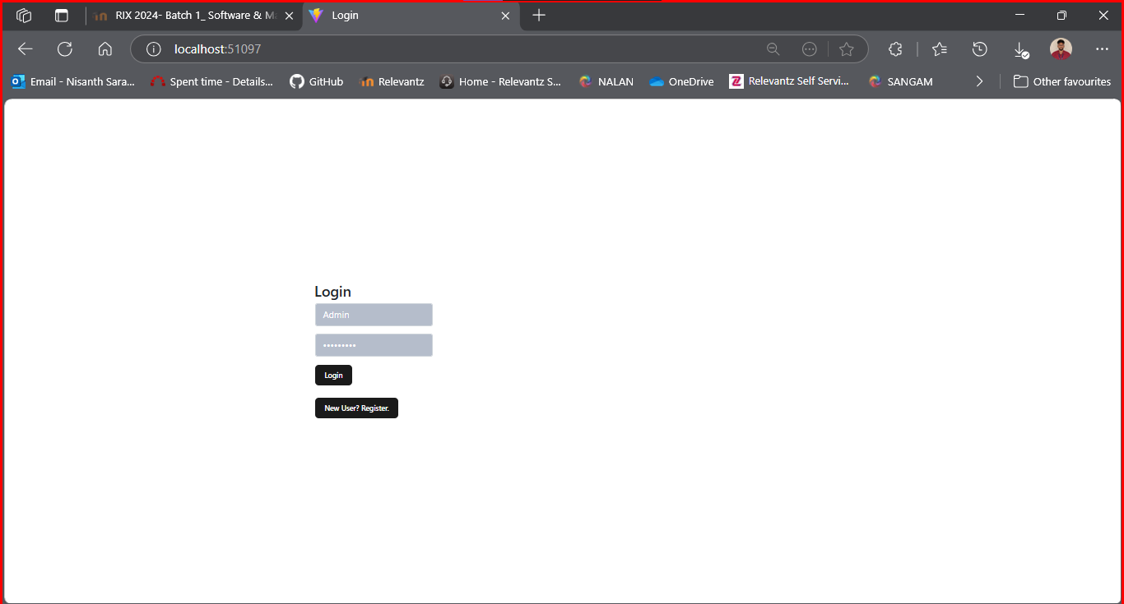

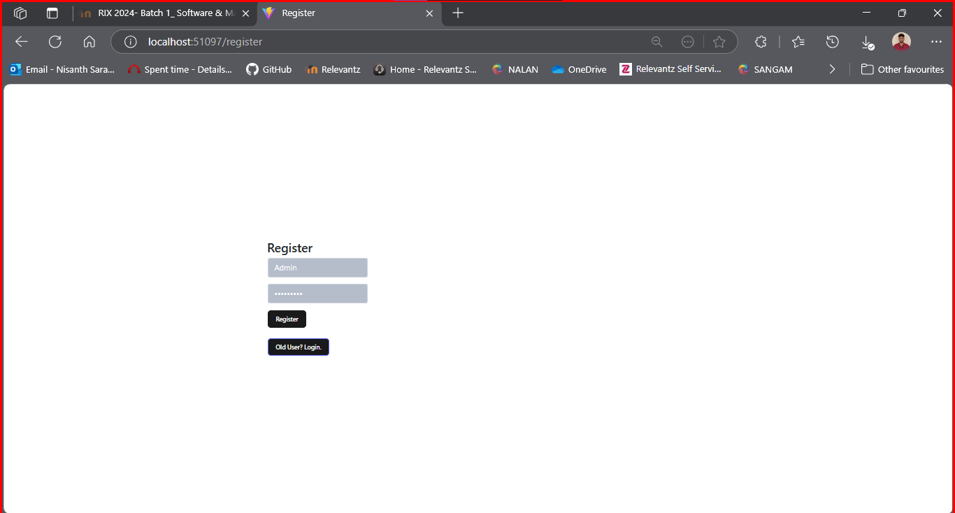

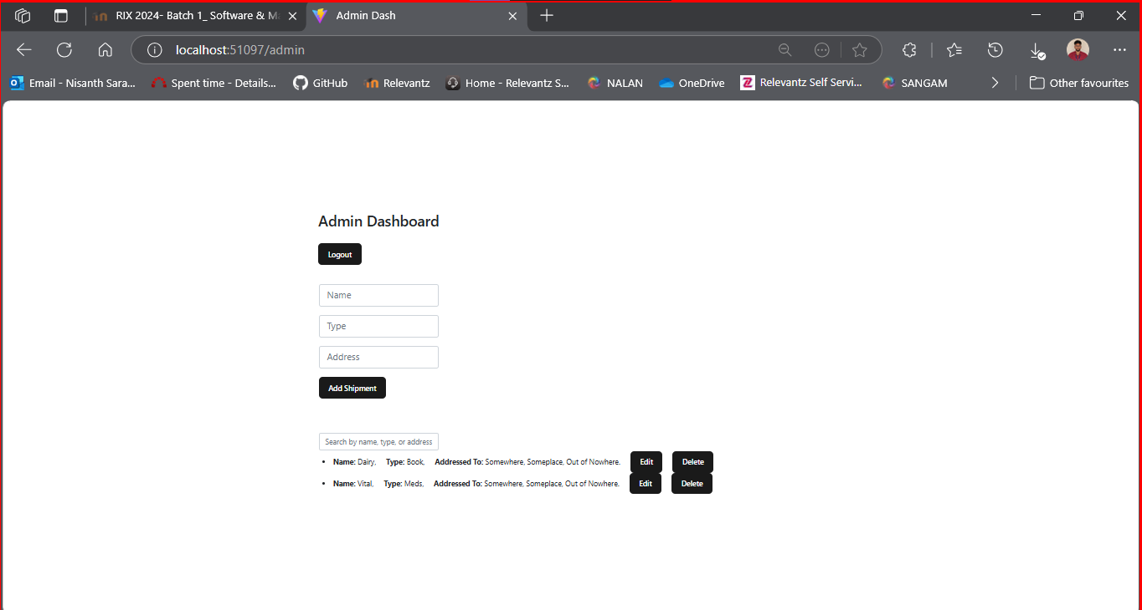

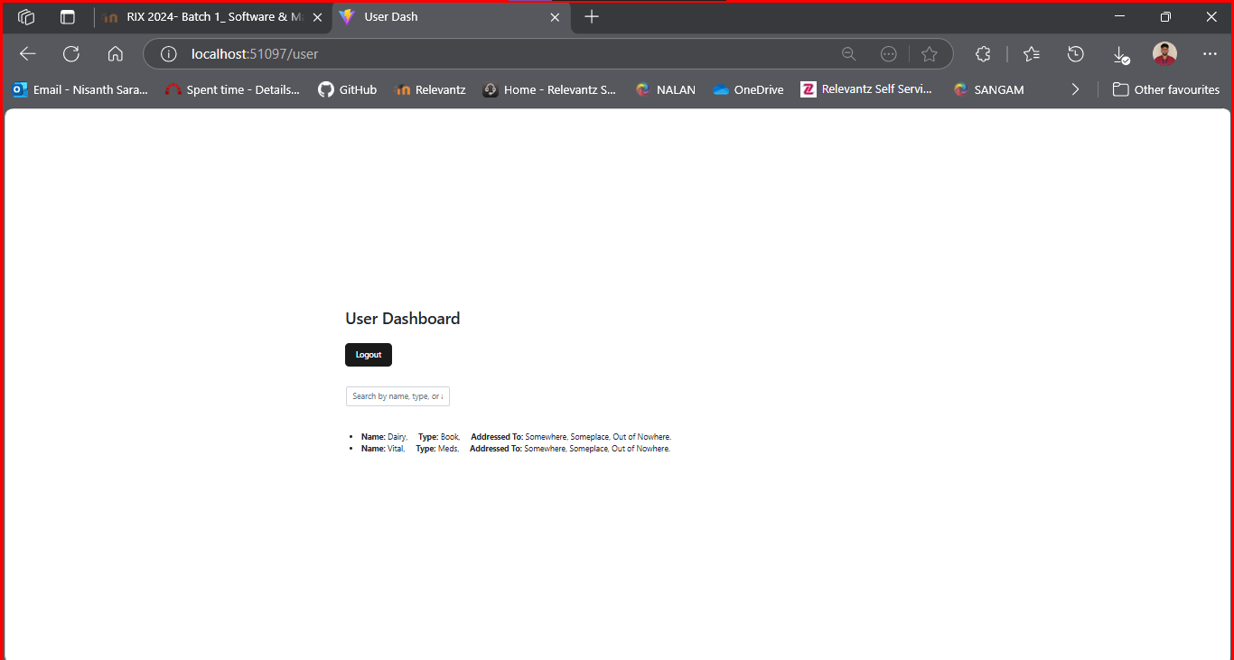
Testing and Result:

Full File:

Login Module:

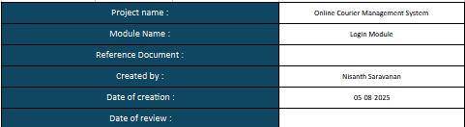

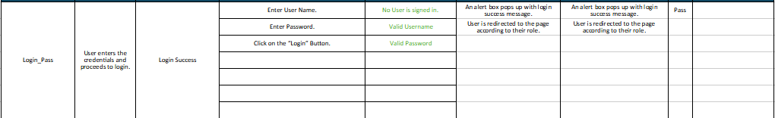

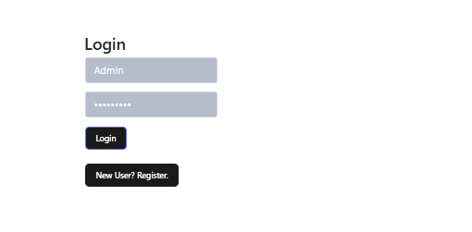

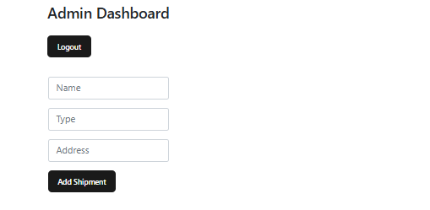
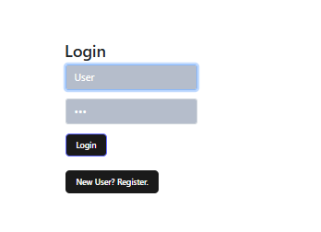

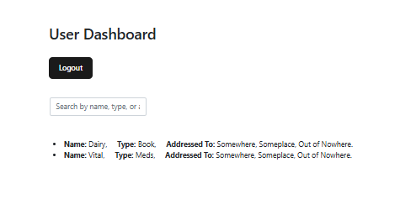
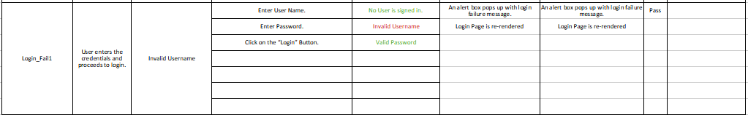

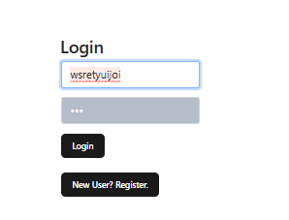

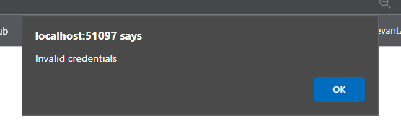

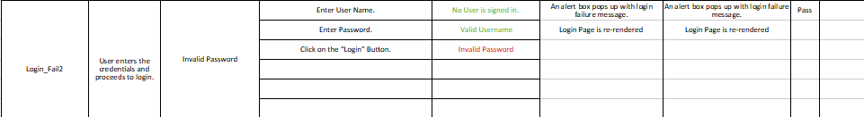

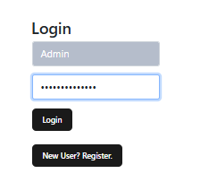

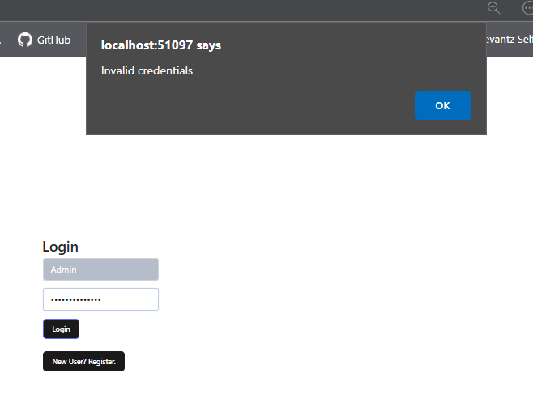
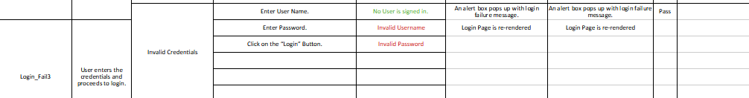

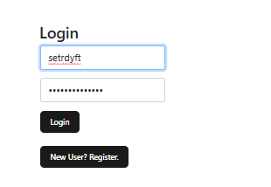

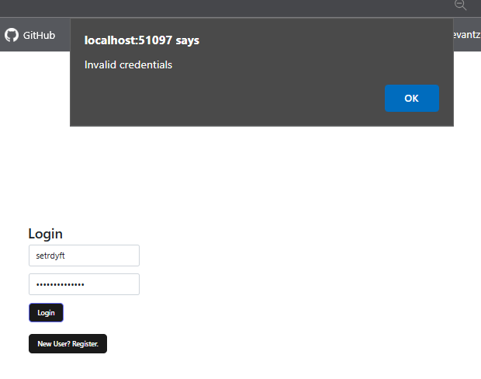

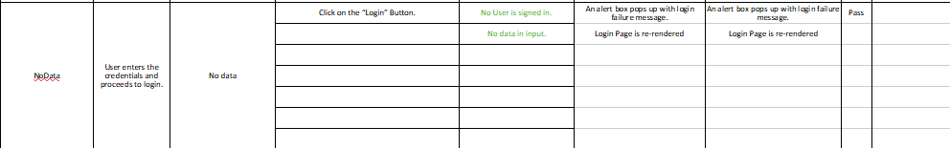

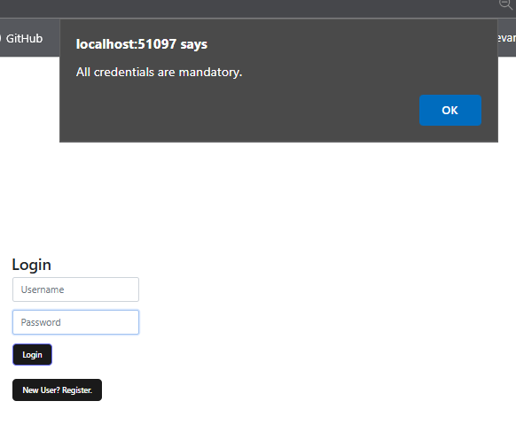
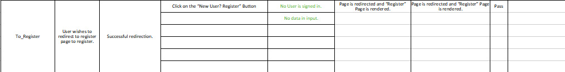

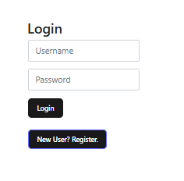

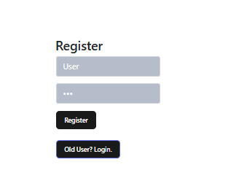
Register Module

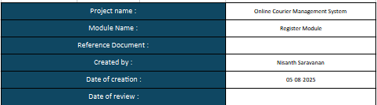

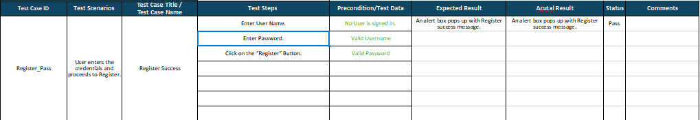

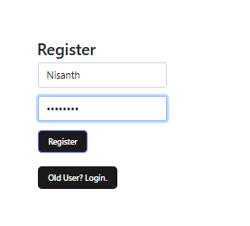

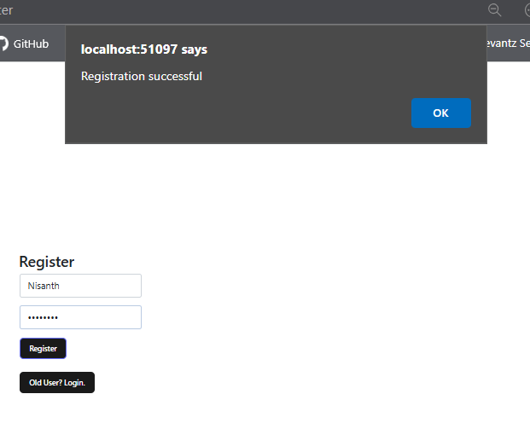

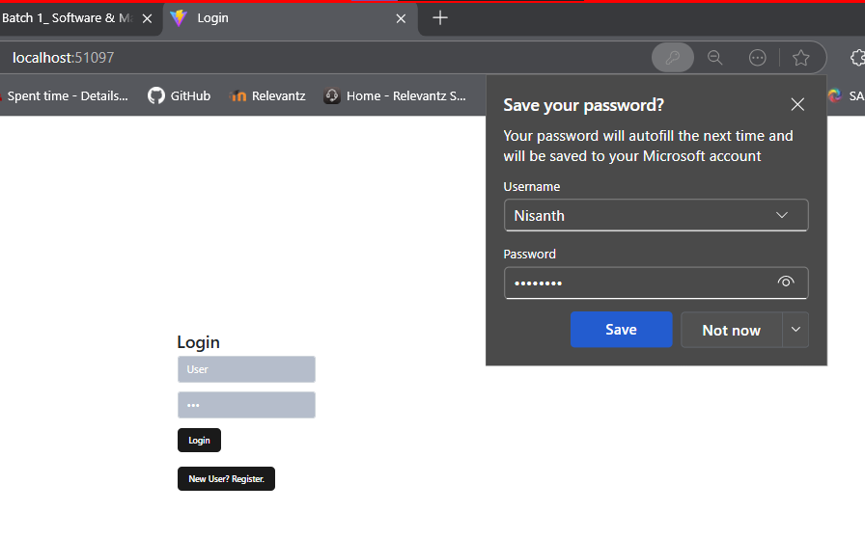
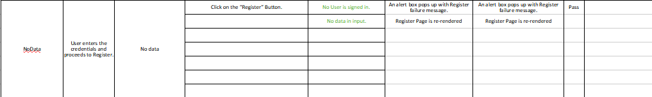

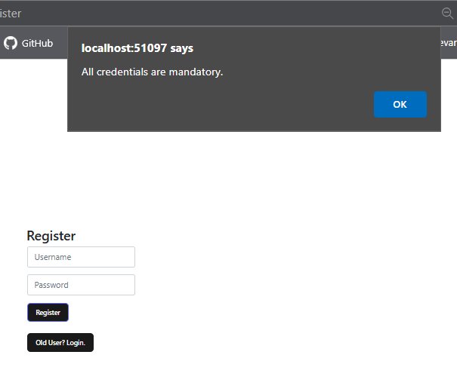
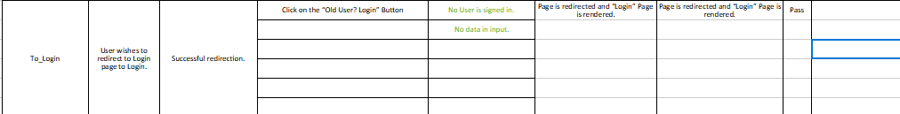

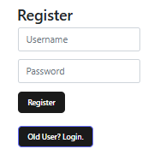

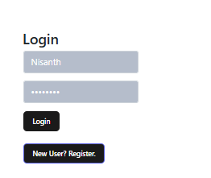
User Module

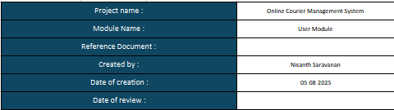

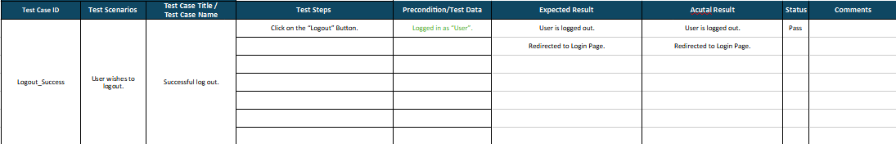

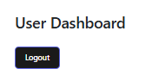

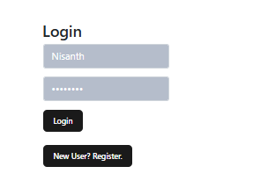
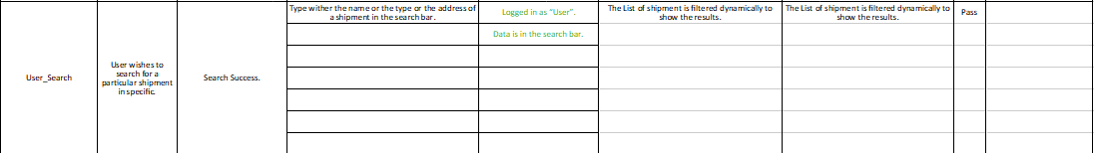

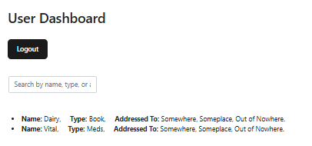

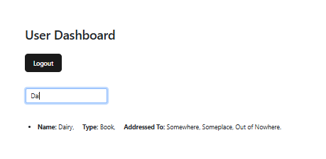

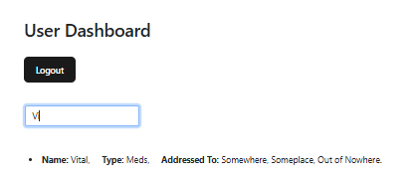
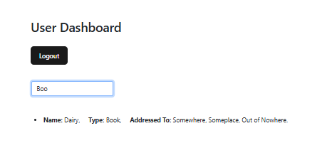

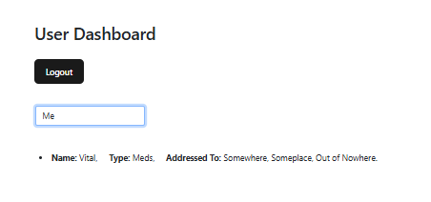

Admin Module

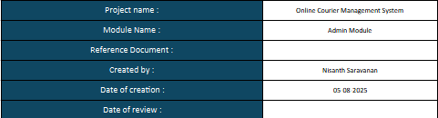

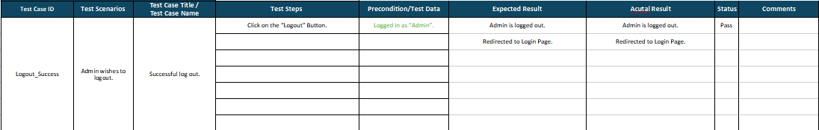

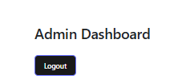

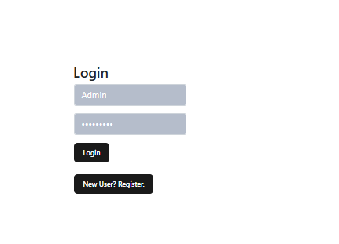
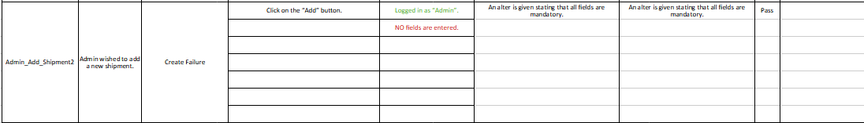

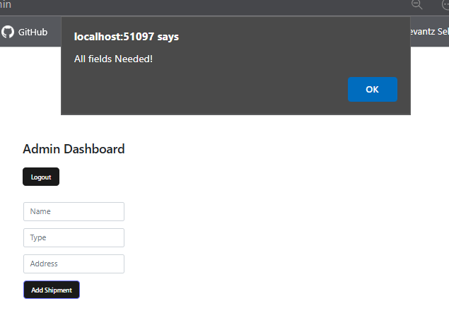
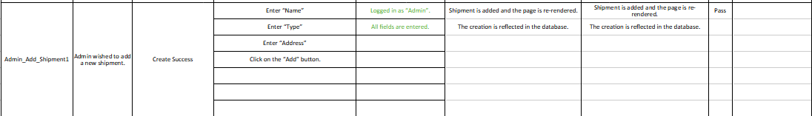

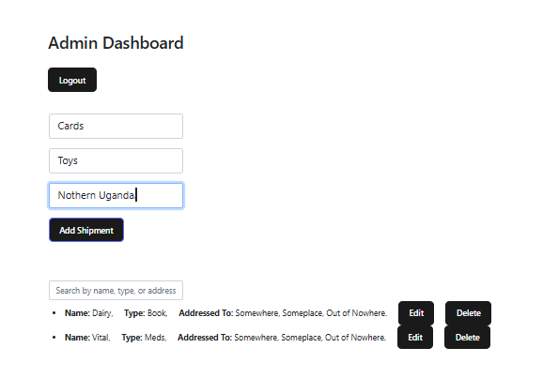

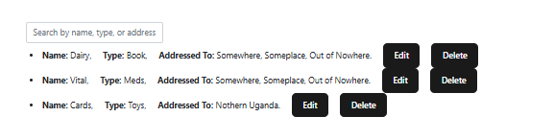
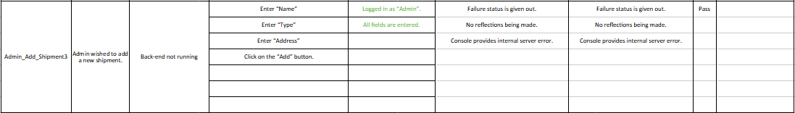

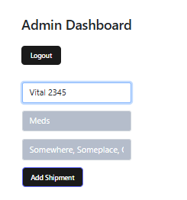

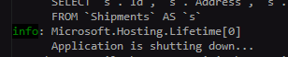

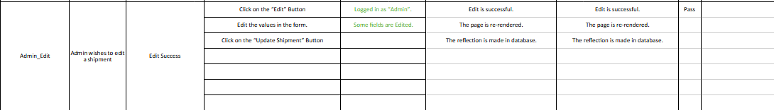

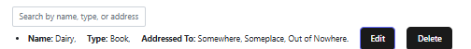

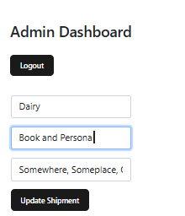

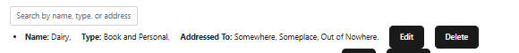
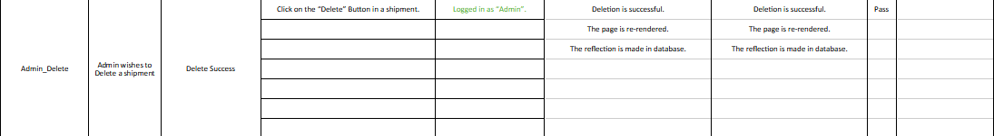

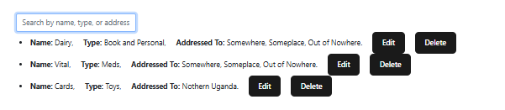

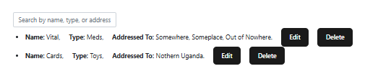
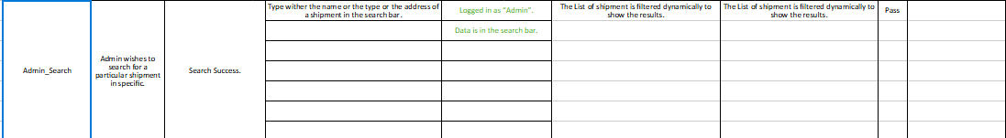

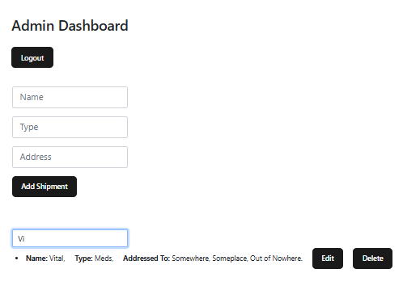

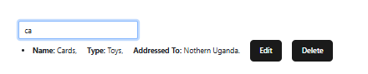

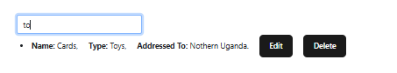

Code Base

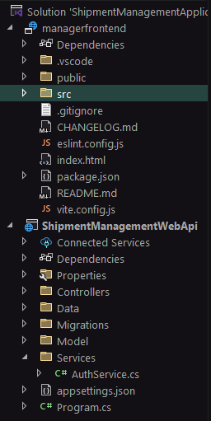
Backend:

/Services/AuthService.cs

using ShipmentManagementWebApi.Data;
using ShipmentManagementWebApi.Models;
using Microsoft.EntityFrameworkCore;

namespace ShipmentManagementWebApi.Services;

public class AuthService
{
private readonly AppDbContext _context;

public AuthService(AppDbContext context)
{
_context = context;
}

public User Authenticate(string username, string password)
{
return _context.Users.FirstOrDefault(u => u.Username == username && u.Password == password);
}

public bool Register(User user)
{
if (_context.Users.Any(u => u.Username == user.Username)) return false;
_context.Users.Add(user);
_context.SaveChanges();
return true;
}
}

appsettings.json

{
"Logging": {
"LogLevel": {
"Default": "Information",
"Microsoft.AspNetCore": "Warning"
}
},
"ConnectionStrings": {
"DefaultConnection": "Server=127.0.0.1;Port=3306;Database=ShipmentDb;User=root;Password=root"
},
"AllowedHosts": "*"
}

Program.cs

using Microsoft.EntityFrameworkCore;
using ShipmentManagementWebApi.Data;
using ShipmentManagementWebApi.Services;

var builder = WebApplication.CreateBuilder(args);

// Add services to the container.

builder.Services.AddControllers();
// Learn more about configuring Swagger/OpenAPI at https://aka.ms/aspnetcore/swashbuckle
builder.Services.AddEndpointsApiExplorer();
builder.Services.AddSwaggerGen();

// Configure EF Core with MySQL
builder.Services.AddDbContext<AppDbContext>(options =>
options.UseMySql(
builder.Configuration.GetConnectionString("DefaultConnection"),
ServerVersion.AutoDetect(builder.Configuration.GetConnectionString("DefaultConnection"))
));

// Register custom services
builder.Services.AddScoped<AuthService>();

builder.Services.AddCors(options =>
{
options.AddPolicy("AllowReactApp",
policy => policy
.WithOrigins("http://localhost:51097") // React dev server
.AllowAnyHeader()
.AllowAnyMethod());
});

var app = builder.Build();

app.UseCors("AllowReactApp");

// Configure the HTTP request pipeline.
if (app.Environment.IsDevelopment())
{
app.UseSwagger();
app.UseSwaggerUI();
}

app.UseHttpsRedirection();

app.UseAuthorization();

app.MapControllers();

app.Run();

/Models/User.cs

using System.ComponentModel.DataAnnotations;

namespace ShipmentManagementWebApi.Models
{
public class User
{
[Key]
public int Id { get; set; }
public string? Username { get; set; }
public string? Password { get; set; } // Plain text for simplicity
public string? Role { get; set; } = "User"; // Default role
}

}

/Models/Shipment.cs

using System.ComponentModel.DataAnnotations;

namespace ShipmentManagementWebApi.Models
{
public class Shipment
{
[Key]
public int Id { get; set; }
public string? Name { get; set; }
public string? Type { get; set; }
public string? Address { get; set; }
}
}

/Data/AppDbContext.cs

using Microsoft.EntityFrameworkCore;
using System.Collections.Generic;
using ShipmentManagementWebApi.Models;

namespace ShipmentManagementWebApi.Data
{
public class AppDbContext : DbContext
{
public AppDbContext(DbContextOptions<AppDbContext> options) : base(options) { }

public DbSet<User> Users { get; set; }
public DbSet<Shipment> Shipments { get; set; }

}
}

/Controllers/AuthController.cs

using Microsoft.AspNetCore.Mvc;
using ShipmentManagementWebApi.Services;
using ShipmentManagementWebApi.Models;

[ApiController]
[Route("api/[controller]")]
public class AuthController : ControllerBase
{
private readonly AuthService _authService;

public AuthController(AuthService authService)
{
_authService = authService;
}

[HttpPost("register")]
public IActionResult Register(User user)
{
user.Role = "User"; // Default role
if (_authService.Register(user)) return Ok("Registered successfully");
return BadRequest("Username already exists");
}

[HttpPost("login")]
public IActionResult Login(User user)
{
var loggedInUser = _authService.Authenticate(user.Username, user.Password);
if (loggedInUser == null) return Unauthorized("Invalid credentials");
return Ok(loggedInUser); // Return user object with role
}
}

/Controllers/ShipmentController.cs

using Microsoft.AspNetCore.Mvc;
using ShipmentManagementWebApi.Data;
using ShipmentManagementWebApi.Models;

[ApiController]
[Route("api/[controller]")]
public class ShipmentController : ControllerBase
{
private readonly AppDbContext _context;

public ShipmentController(AppDbContext context)
{
_context = context;
}

[HttpGet]
public IActionResult GetAll() => Ok(_context.Shipments.ToList());

[HttpGet("{id}")]
public IActionResult Get(int id)
{
var shipment = _context.Shipments.Find(id);
if (shipment == null) return NotFound();
return Ok(shipment);
}

[HttpPost]
public IActionResult Create(Shipment shipment, [FromQuery] string role)
{
if (role != "Admin") return Unauthorized("Only admin can create shipments");
_context.Shipments.Add(shipment);
_context.SaveChanges();
return Ok(shipment);
}

[HttpPut("{id}")]
public IActionResult Update(int id, Shipment updatedshipment, [FromQuery] string role)
{
if (role != "Admin") return Unauthorized("Only admin can update shipments");
var shipment = _context.Shipments.Find(id);
if (shipment == null) return NotFound();

shipment.Name = updatedshipment.Name;
shipment.Type = updatedshipment.Type;
shipment.Address = updatedshipment.Address;

_context.SaveChanges();
return Ok(shipment);
}

[HttpDelete("{id}")]
public IActionResult Delete(int id, [FromQuery] string role)
{
if (role != "Admin") return Unauthorized("Only admin can delete shipments");
var shipment = _context.Shipments.Find(id);
if (shipment == null) return NotFound();

_context.Shipments.Remove(shipment);
_context.SaveChanges();
return Ok("Deleted");
}
}

Frontend – React JS

/src/main.jsx

import React from 'react';
import ReactDOM from 'react-dom/client';
import App from './App';
import { AuthProvider } from './context/AuthContext';
import "./index.css";

const root = ReactDOM.createRoot(document.getElementById('root'));
root.render(
<AuthProvider>
<App />
</AuthProvider>
);

/src/App.jsx

import React, { useContext } from 'react';
import { BrowserRouter as Router, Routes, Route, Navigate } from 'react-router-dom';
import Login from './components/Login';
import Register from './components/Register';
import AdminDashboard from './components/AdminDashboard';
import UserDashboard from './components/UserDashboard';
import { AuthContext } from './context/AuthContext';
import "./App.css";

function App() {
const { user } = useContext(AuthContext);

return (
<Router>
<Routes>
<Route path="/" element={<Login />} />
<Route path="/register" element={<Register />} />
<Route path="/admin" element={user?.role === 'Admin' ? <AdminDashboard /> : <Navigate to="/" />} />
<Route path="/user" element={user?.role === 'User' ? <UserDashboard /> : <Navigate to="/" />} />
</Routes>
</Router>
);
}

export default App;

/services/api.js

//api.js
import axios from 'axios';

const API = axios.create({
baseURL: 'http://localhost:5099/api', // Adjust if needed
});

export default API;

/context/AuthContext.jsx

//AuthContext.jsx
import React, { createContext, useState } from 'react';

// eslint-disable-next-line react-refresh/only-export-components
export const AuthContext = createContext();

export const AuthProvider = ({ children }) => {
const [user, setUser] = useState(null); // Holds logged-in user

return (
<AuthContext.Provider value={{ user, setUser }}>
{children}
</AuthContext.Provider>
);
};

/components/Login.jsx

import React, { useState, useContext, useEffect } from 'react';
import { useNavigate } from 'react-router-dom';
import API from '../services/api';
import { AuthContext } from '../context/AuthContext';

function Login() {
const [username, setUsername] = useState('');
const [password, setPassword] = useState('');
const { setUser } = useContext(AuthContext);
const { user } = useContext(AuthContext);
const navigate = useNavigate();

const handleLogin = async () => {

if (username == '' || password == '') {
alert("All credentials are mandatory.");
return;
}

try {
const res = await API.post('/auth/login', { username, password });
setUser(res.data);
res.data.role === 'Admin' ? navigate('/admin') : navigate('/user');
} catch {
alert('Invalid credentials');
}
};

const handleRegister = () => {
navigate('/register');
}

useEffect(() => {
document.title = "Login";

if (user?.role == "Admin") {
navigate("/admin");
}
else if (user?.role == "User") {
navigate("/user")
}
});

return (
<>
<div class="container">
<h2>Login</h2>
<table>
<tr>
<td>
<div class="input-group input-group-lg mb-3">
<input class="form-control" placeholder="Username" onChange={e => setUsername(e.target.value)} />
</div>
</td>
</tr>
<tr>
<td>
<div class="input-group input-group-lg mb-3">
<input class="form-control" placeholder="Password" type="password" onChange={e => setPassword(e.target.value)} />
</div>
</td>
</tr>
<tr>
<td>
<button onClick={handleLogin}>Login</button>
</td>
</tr>
<br></br>
<tr>
<td>
<button onClick={handleRegister}>New User? Register.</button>
</td>
</tr>
</table>
</div>
</>
);
}

export default Login;

/components/Register.jsx

import React, { useState, useEffect, useContext } from 'react';
import { useNavigate } from 'react-router-dom';
import API from '../services/api';
import { AuthContext } from '../context/AuthContext';

function Register() {
const [username, setUsername] = useState('');
const [password, setPassword] = useState('');
const { user } = useContext(AuthContext);
const navigate = useNavigate();

const handleRegister = async () => {

if (username == '' || password == '') {
alert("All credentials are mandatory.");
return;
}

try {
await API.post('/auth/register', { username, password });
alert('Registration successful');
navigate("/");
} catch {
alert('Registration failed');
}
};

const handleLogin= () => {
navigate('/');
}

useEffect(() => {
document.title = "Register";

if (user?.role == "Admin") {
navigate("/admin");
}
else if (user?.role == "User") {
navigate("/user")
}
});

return (
<>
<div class="container">
<h2>Register</h2>
<table>
<tr>
<td>
<div class="input-group input-group-lg mb-3">
<input class="form-control" placeholder="Username" onChange={e => setUsername(e.target.value)} />
</div>
</td>
</tr>
<tr>
<td>
<div class="input-group input-group-lg mb-3">
<input class="form-control" placeholder="Password" type="password" onChange={e => setPassword(e.target.value)} />
</div>
</td>
</tr>
<tr>
<td>
<button onClick={handleRegister}>Register</button>
</td>
</tr>
<br></br>
<tr>
<td>
<button onClick={handleLogin}>Old User? Login.</button>
</td>
</tr>
</table>
</div>
</>
);
}

export default Register;

/components/AdminDashboard.jsx

import React, { useContext, useEffect, useState } from 'react';
import API from '../services/api';
import { AuthContext } from '../context/AuthContext';

function AdminDashboard() {
const { user } = useContext(AuthContext);
const [shipments, setShipment] = useState([]);
const { setUser } = useContext(AuthContext);
const [searchTerm, setSearchTerm] = useState('');
const [form, setForm] = useState({ name: '', type: '', address: ''});
const [editingId, setEditingId] = useState(null);

const fetchShipments = async () => {
const res = await API.get('/shipment');
setShipment(res.data);
};

const createOrUpdateShipment = async () => {

if (form.name == '' || form.type == '' || form.address == '') {
alert("All fields Needed!");
return;
}

if (editingId) {
await API.put(`/shipment/${editingId}?role=${user.role}`, form);
setEditingId(null);
} else {
await API.post(`/shipment?role=${user.role}`, form);
}
setForm({ name: '', type: '', address: '' });
fetchShipments();
};

const deleteShipment = async (id) => {
await API.delete(`/shipment/${id}?role=${user.role}`);
fetchShipments();
};

const startEdit = (shipment) => {
setForm(shipment);
setEditingId(shipment.id);
};

const filteredShipments = shipments.filter(s =>
s.name.toLowerCase().includes(searchTerm.toLowerCase()) ||
s.type.toLowerCase().includes(searchTerm.toLowerCase()) ||
s.address.toString().includes(searchTerm)
);

const logout = () => {
setUser(null);
};

useEffect(() => {
document.title = "Admin Dash";

fetchShipments();
}, []);

return (
<div class="container">
<h2>Admin Dashboard</h2>
<br></br>
<button onClick={logout} style={{ marginBottom: '1rem' }}>
Logout
</button>
<br></br>
<br></br>
<table>
<tr>
<td>
<div class="input-group input-group-lg mb-3">
<input class="form-control" placeholder="Name" value={form.name} onChange={e => setForm({ ...form, name: e.target.value })} />
</div>
</td>
</tr>
<tr>
<td>
<div class="input-group input-group-lg mb-3">
<input class="form-control" placeholder="Type" value={form.type} onChange={e => setForm({ ...form, type: e.target.value })} />
</div>
</td>
</tr>
<tr>
<td>
<div class="input-group input-group-lg mb-3">
<input class="form-control" placeholder="Address" value={form.address} onChange={e => setForm({ ...form, address: e.target.value })} />
</div>
</td>
</tr>
<tr>
<td>
<button onClick={createOrUpdateShipment}>
{editingId ? 'Update Shipment' : 'Add Shipment'}
</button>
</td>
</tr>
<br></br>
<br></br>
<br></br>
<tr>
<td>
<input
class="form-control"
placeholder="Search by name, type, or address"
value={searchTerm}
onChange={e => setSearchTerm(e.target.value)}
/>
</td>
</tr>
</table>
<ul>
{filteredShipments.map(s => (
<li key={s.id}>
<strong>Name:</strong> {s.name},&nbsp;&nbsp;&nbsp;&nbsp; <strong>Type:</strong> {s.type},&nbsp;&nbsp;&nbsp;&nbsp; <strong>Addressed To:</strong> {s.address} &nbsp;&nbsp;&nbsp;&nbsp;
<button onClick={() => startEdit(s)}>Edit</button> &nbsp;&nbsp;&nbsp;&nbsp;
<button onClick={() => deleteShipment(s.id)}>Delete</button>
</li>
))}
</ul>
</div>
);
}

export default AdminDashboard;

/components/UserDashboard.jsx

import React, { useContext, useEffect, useState } from 'react';
import API from '../services/api';
import { AuthContext } from '../context/AuthContext';

function UserDashboard() {
const [shipments, setShipment] = useState([]);
const [searchTerm, setSearchTerm] = useState('');
const { setUser } = useContext(AuthContext);

useEffect(() => {
document.title = "User Dash";

API.get('/shipment').then(res => setShipment(res.data));
}, []);

const logout = () => {
setUser(null);
};

const filteredShipments = shipments.filter(s =>
s.name.toLowerCase().includes(searchTerm.toLowerCase()) ||
s.type.toLowerCase().includes(searchTerm.toLowerCase()) ||
s.address.toString().includes(searchTerm)
);

return (
<div class="container">
<h2>User Dashboard</h2>
<br></br>
<button onClick={logout} style={{ marginBottom: '1rem' }}>
Logout
</button>
<br></br>
<br></br>
<table>
<tr>
<td>
<input
class="form-control"
placeholder="Search by name, type, or address"
value={searchTerm}
onChange={e => setSearchTerm(e.target.value)}
/>
</td>
</tr>
</table>
<br></br>
<br></br>
<ul>
{filteredShipments.map(s => (
<li key={s.id}>
<strong>Name:</strong> {s.name},&nbsp;&nbsp;&nbsp;&nbsp; <strong>Type:</strong> {s.type},&nbsp;&nbsp;&nbsp;&nbsp; <strong>Addressed To:</strong> {s.address} &nbsp;&nbsp;&nbsp;&nbsp;
</li>
))}
</ul>
</div>
);
}

export default UserDashboard;

